Access Control Functions

* Preventative
  + Controls used to STOP undesirable events from taking place
* Detective
  + Controls used to identify undesirable events that have occurred
* Corrective
  + Controls used to correct the effects of undesirable events
* Deterrent
  + Controls used to **DISCOURAGE** security violations
* Recovery
  + Controls used to restore resources and capabilities
* Compensation
  + [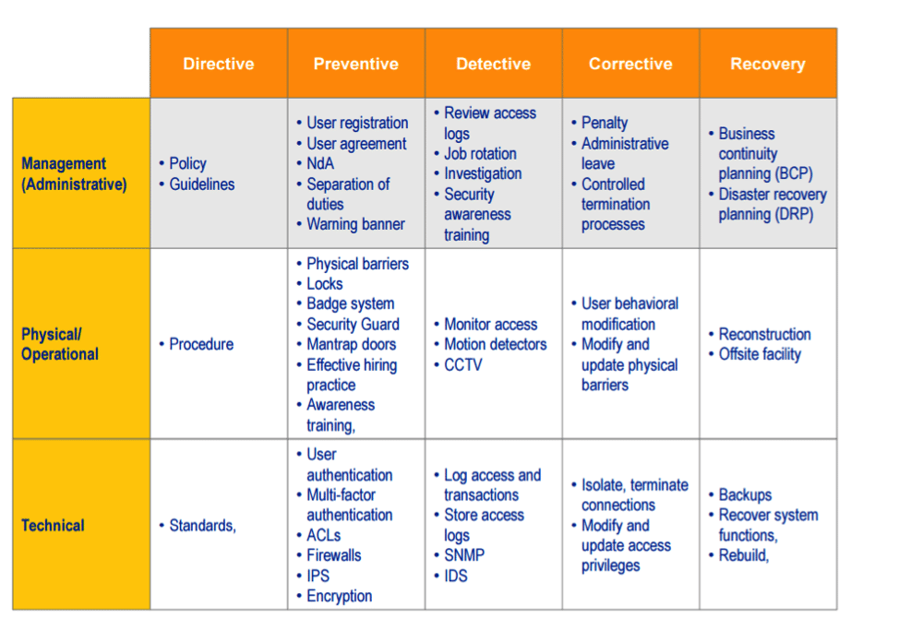](https://www.google.com/url?sa=i&url=https%3A%2F%2Fresources.infosecinstitute.com%2Fcissp-risk-management-concepts-2%2F&psig=AOvVaw2mvh5EZcowI-GkK_QvffAt&ust=1597479786373000&source=images&cd=vfe&ved=0CAIQjRxqFwoTCMDTqI6imusCFQAAAAAdAAAAABAE) Controls used to provide alternative solutions